|  |  |
| --- | --- |
| **FLASH NOTE:** **Assessment of Vinpearl's Listing Activities** | Research Department |
|  | 12/3/2025 |

|  |
| --- |
| **CONTENTS** |

**1/ COMPANY OVERVIEW**

Vinpearl is one of the first two key components that formed Vingroup (HoSE: VIC). Vingroup's predecessor was Technocom Group, founded in 1993 in Ukraine. In the early 2000s, Technocom returned to Vietnam, focusing its investments on tourism and real estate with two initial strategic brands: Vinpearl and Vincom. Vinpearl, established in 2001, was the first company within the Vingroup ecosystem and was founded even before the current parent company. At present, Vingroup remains the largest shareholder in Vinpearl, holding an 85.51% stake in its charter capital.

**Business Sectors:**

The company's core business is providing tourism, hotel and resort services. According to the website, the company currently manages and operates 48 facilities in 18 provinces and cities nationwide, including:

* 31 hotels and resorts with a total capacity of over 16,100 rooms, located in major coastal cities such as Phu Quoc, Nha Trang, Da Nang, Hoi An, Ha Long, etc.
* 4 theme parks
* 5 entertainment complexes
* 1 semi-wildlife conservation park
* 1 water park
* 1 horse academy
* 4 golf courses
* 1 culinary and convention center

**Resort real estate development:** Vinpearl is also a pioneer in introducing condotel apartments to Vietnam’s resort real estate market. The company provides management and rental services for customers who purchase villas and hotel apartments.

Its resort real estate business has expanded through capital investment in tourism real estate projects in collaboration with subsidiaries and affiliated companies. These projects are strategically located in prime tourist destinations across Vietnam, including Nha Trang, Hoi An, Da Nang, and Da Lat,…)

**Subsidiaries**

|  |  |  |  |
| --- | --- | --- | --- |
| **Subsidiaries** | **Charter Capital**  **(billion VND)** | **% Ownership** | **Project in progress** |
| **Phuc An Travel Development And Investment Limited Liabilitiy Company** | 502.75 | 99.00% |  |
| **Landmark 81 Hotel Investment and Development Joint Stock Company** | 1,605.5 | 99.99% |  |
| **Thanh Hoa Hotel Investment and Development Joint Stock Company** | 687 | 99.99% |  |
| **Vinwonders Nha Trang Joint Stock Company** | 2,918.8 | 99.99% | VinWonder Nha Trang entertainment project |

*Source: VPL, GTJASVN Research*

**VINPEARL (VPL)** **Development History**

|  |  |
| --- | --- |
| **Timeline** | **Activities** |
| **25/07/2001** | ***Hon Tre Tourism Development, Trading and Service Investment Company Limited,*** the predecessor of Vinpearl, was established; located on Hon Tre Island, Vinh Nguyen Ward, Nha Trang City, Khanh Hoa Province.  Charter capital of 60 billion VND.  Main business lines: hotel business, eco-tourism area, restaurant, entertainment services, grocery sales,... |
| **6/9/2002** | ***Changed name to Hon Tre Tourism and Trading Limited Liability Company*** |
| **2003** | Increased charter capital to 290 billion VND |
| **26/07/2006** | Officially converted the business type and changed the name to ***Vinpearl Tourism and Trading Joint Stock Company*** |
| **2008** | First listing on HoSE with stock code **VPL** |
| **2011** | ***Vinpearl merged with Vincom to form Vingroup, resulting in VPL shares being exchanged for VIC shares.*** After the merger, Vinpearl was reorganized into a single-member limited liability company wholly owned by Vincom.  As of October 26, 2011, Vinpearl had a charter capital of 2,055 billion VND and a market capitalization of 16,132 billion VND |
| **11/2024** | Completed the registration to become a public company |
| **2/2025** | Successfully issued over 70 million shares at an offering price of 71,350 VND per share to 105 domestic investors, raising over 5,000 billion VND and increasing charter capital to nearly 18,000 billion VND. |
| **3/2025** | The Ho Chi Minh City Stock Exchange (HOSE) announced that it has received the listing registration file for more than 1.793 billion shares of Vinpearl Joint Stock Company (stock code: **VPL**) |

*Source: VPL, GTJASVN Research*

**2/ BUSINESS ANALYSIS**

**Tourism services:** dependent on economic conditions; thus, highly volatile

* ***From 2016 to 2019***, Vinpearl experienced positive business performance, with high revenue growth. During this period, The number of hotel and villa projects increased significantly from 9 to 33, while the total number of rooms continuously expanded, reflecting the company’s rapid development in the hospitality sector..

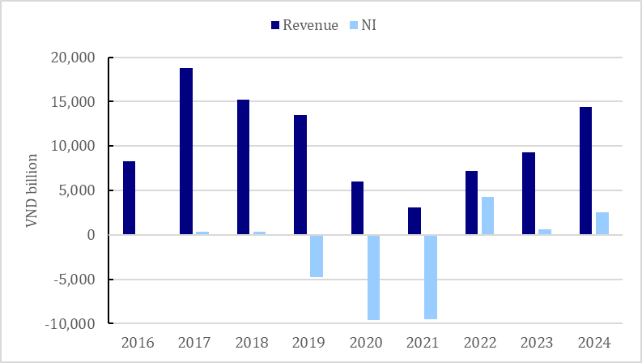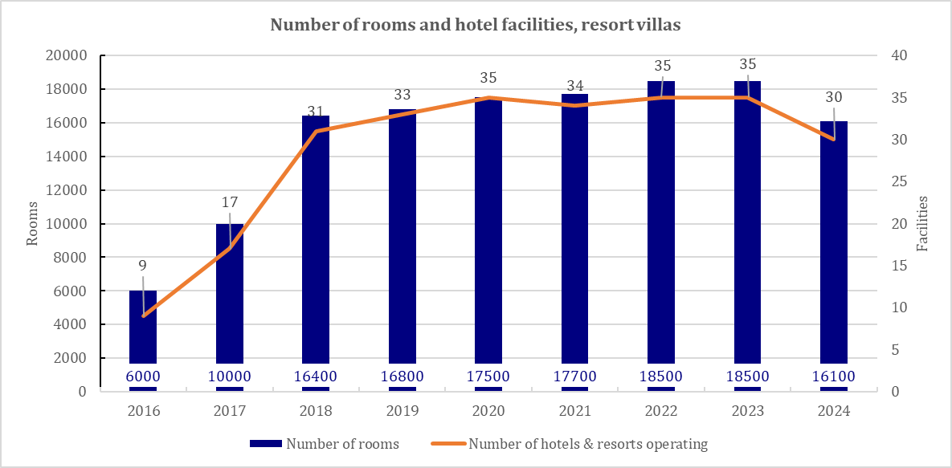

*Source: VPL, GTJASVN Research*

* ***2020 – 2021:*** Operating in one of the most industries harmed by the Covid-19 Pandemic, Vinpearl experienced a sharp decline in business performance. Revenue from hospitality and entertainment services plummeted from VND 13,512 billion in 2019 to VND 3,049 billion in 2021. Despite the significant revenue drop, the company still had to cover operating costs, depreciation, maintenance expenses, and profit commitments under the condotel model. As a result, net losses surged from nearly VND 4,000 billion to VND 10,000 billion annually. By the end of 2021, Vinpearl’s accumulated losses had reached VND 23,559 billion (~USD 1 billion), with VND 20,300 billion of losses recorded in 2020 and 2021 alone.

The number of guest nights decreased sharply in 2020 and 2021 to 2.2 and 2 million guest nights respectively from 4.9 million guest nights, mainly domestic guests accounting for 60-80%. While in previous years, foreign guests accounted for over 70% and mainly came from China, Korea and Russia. Similarly, the number of visitors to VinWonders entertainment area also decreased sharply from 5.8 million in 2019 to 2.9 million in 2020 and 1.1 million in 2021.

*Source: VPL*

* ***2022 - 2023:*** After overcoming the challenging period, Vinpearl recorded positive profits again for the first time since 2022. However, the gross profit margin for the hospitality and tourism services segment remained low. In 2023, the cost of goods sold (COGS) exceeded revenue, reaching 1.23 times the total revenue of this segment.

*Source: VPL, GTJASVN Research*

**The resort real estate business** remained sluggish from 2019 to 2023, in line with the overall downturn of the market for this type of housing.

**Vinpearl recently announced its audited consolidated financial statements for 2024 with the following outstanding business performance indicators:**

|  |  |  |  |  |
| --- | --- | --- | --- | --- |
| **Items** | **2023** | **2024** | **YoY Growth** |  |
| **Net revenue** | **9,254** | **14,376** | 55% |  |
| *Hotel, tourism and entertainment services* | 8,612 | 8,498 | -1% | Revenue from the core business slightly decreased |
| *Real Estate Transfer* | 569 | 5,890 | 9.34x | Revenue from real estate transfers increased more than ninefold compared to the previous year, serving as the main growth driver that pushed total revenue to VND 14,388 billion, up 55.3% from VND 9,265 billion in the previous year. |
| *Others* | 84 | 0 | - |  |
| **Cost of goods sold** | **11,823** | **11,513** | -3% |  |
| *Hotel, tourism and entertainment services* | 11,688 | 7,546 | -35% |  |
| *Real Estate Transfer* | 134 | 3,967 | 28.7 |  |
| *Others* | 2 | 0 | - |  |
| **Gross profit** | **-2,569** | **2,863** | - |  |
| *Hotel, tourism and entertainment services* | **-3,076** | **952** | -131% |  |
| *Real Estate Transfer* | **436** | **1,923** | 3.41x |  |
| *Others* | **82** | **0** | - |  |
| ***%Gross margin*** |  |  |  |  |
| *Hotel, tourism and entertainment services* | **-36%** | **11%** | - | The number of resorts and rooms under Vinpearl decreased in 2024 due to the company’s restructuring efforts, which included transferring or closing underperforming properties to focus on more profitable projects. The gross profit margin shifted from negative to positive, driven primarily by the significant contribution from real estate transfer revenue. |
| *Real Estate Transfer* | **77%** | **33%** | - |  |
| *Others* | **98%** | **-** | - |  |
| **Financial activity revenue** | **8,728** | **4,264** | -51% | Financial activity revenue recorded an extraordinary profit in 2023 of more than VND 5,000 billion from the transfer of VHM shares to Vingroup and shares at SADO. Thereby contributing to the positive after-tax profit in 2023 despite the negative gross profit. |
| **Interest Expense** | **-3,898** | **-1,740** | -55% |  |
| **SG&A** | -1,518 | -2,282 | 50% |  |
| **Income before taxes** | **743** | **3,105** | 3.18x |  |
| **Net profit** | **671** | **2,550** | 2.8x |  |

*Source: VPL, GTJASVN Research*

**As of the end of 2024, Vinpearl’s total assets reached VND 76,483 billion, marking a 73.5% increase compared to 2023.** Notable fluctuations were observed across various asset categories:

* **Short-term receivables:** Recorded VND 12,464 billion, while there was no such item at the beginning of the year. These are intercompany loans in the same group, provided to Vincom Security Services Co., Ltd., Vinpearl Cua Hoi JSC, Vinacademy Education and Training Co., Ltd., and Vinsmart Research and Production JSC.
* **Inventory:** Increased by nearly 6,000 VND billion.
* **Long-term asset in progress:** Reached VND 5,029 billion, accounting for 6.5% of total assets (+26% YoY). Key projects include: Vinpearl Phu Quy Residential Project (VND 1,130 billion); VinWonders Entertainment Projects (VND 956 billion); Hon Tre Island Development Project (VND 974 billion); Con Au 18-hole Golf Course Project (VND 711 billion)
* **Goodwill:** Recorded nearly VND 5,000 billion, arising from Vinpearl's acquisition of a 99.99% stake in VinWonders Nha Trang JSC, Vinpearl Thanh Hoa, and Vinpearl Landmark 81 from a partner in February 2024

**Capital structure:**

* Total liabilities: Nearly VND 45,000 billion, up 46% compared to the beginning of the year.
* Total debt: Nearly VND 12,900 billion, with a shift from short-term to long-term debt.
* Short-term advances from customers: Surged to over VND 13,500 billion, compared to VND 443 billion at the beginning of the year, mainly arising from sales contracts for commercial and residential areas of the Vinpearl Phu Quy Residential Project with four partners.
* It can be seen that in 2024 and early 2025, Vinpearl has restructured to improve the quality of its balance sheet thanks to revenue from real estate transfers (as mentioned above) along with shifting the debt structure from short-term to long-term, as well as the purchase of more than VND 10,000 billion of international bonds before maturity within 1 month (December 2024 - January 2025), showing a debt reduction strategy.

**Asset structure Capital structure**

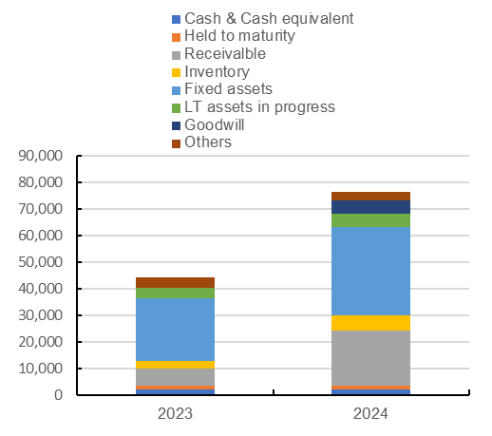

*Source: VPL, GTJASVN Research*

**Equity** increased sharply in 2024 from VND 13,317 billion to VND 31,483 billion due to the transfer of shares from Vingroup and internal restructuring and increased retained earnings (thanks to increased profits). Specifically**:**

Vinpearl used the capital mobilized from the issuance of shares to receive the transfer of shares from Vingroup (VIC) or other investors, then carried out internal restructuring, including:

* Landmark 81 Hotel Investment and Development Joint Stock Company: Vinpearl received the transfer of 160.5 million shares (equivalent to 99.99% ownership ratio) on February 23, 2024 and February 26, 2024.
* Thanh Hoa Hotel Investment and Development Joint Stock Company: Received 68.7 million shares (99.99% ownership ratio) at the same time.
* VinWonders Nha Trang Joint Stock Company: Received 291.9 million shares (99.99% ownership ratio).

**Comment:**

It is evident that Vinpearl’s core business in the hotel and tourism sector remains in a slow recovery phase after the pandemic, with revenue growth yet to show a strong breakthrough. The recent profit surge has primarily resulted from financial restructuring activities, including real estate asset transfers, divestments from joint ventures, and internal cash flow optimization within the Vingroup ecosystem. However, these one-off transactions do not create long-term sustainable growth momentum for the company.

A key highlight in Vinpearl’s development strategy is its resort expansion efforts, particularly investments in VinWonders Nha Trang and the acquisition of Vinpearl Cua Hoi. These steps enhance scale and reinforce the company’s position in the hospitality and tourism industry.

However, the biggest challenge remains capital management, as the company is increasing debt to finance new projects amid volatile capital and financial markets. Securing a stable funding source, particularly through an IPO, will be critical for Vinpearl’s ability to maintain and drive sustainable growth in the future.

**3/ VINPEARL'S LISTING ACTIVITIES**

**At the 2024 Annual General Meeting of Shareholders (AGM) held in April**, Chairman Pham Nhat Vuong stated that the Group was carrying out procedures to list Vinpearl on the Vietnamese stock exchange and expressed hopes for a successful listing by the end of the year.

**By the end of 2024**, Vinpearl had been approved by the State Securities Commission of Vietnam (SSC) to become a public company.

According to the latest update, the Ho Chi Minh City Stock Exchange (HOSE) had received Vinpearl Joint Stock Company’s (ticker symbol: VPL) listing application for over 1.793 billion shares **in early March 2025.**

Based on market practices, VPL shares are highly likely to be officially listed around Q3–Q4/2025.

In early February this year, the company successfully raised over VND 5,000 billion from the issuance of more than 70 million shares to 105 investors at a price of VND 71,350 per share. With an expected listing price of VND 71,350 per share, Vinpearl’s market capitalization would reach approximately VND 127 trillion, placing it among the largest-cap stocks on the Vietnamese stock market.

Regarding liquidity and listing strategy, there is still no certainty about VPL's liquidity after listing. According to the prospectus released at the end of last year, Vinpearl had only one major shareholder—its parent company, Vingroup—holding 85.5% of shares as of the end of 2024. The remaining 14.49% belonged to other shareholders, which would also be the free float ratio when the stock is listed.

**Comparison with listed Vingroup subsidiaries:**

|  |  |  |  |  |
| --- | --- | --- | --- | --- |
| Subsidiaries | Listed year | IPO issuance rate | Capital Raising Objectives | Notes |
| Vinhomes | 2018 | 10% | Real estate development | Largest capitalization at the time of listing |
| Vincom Retail | 2017 | 20% | Expansion of shopping malls | Increase liquidity |
| Vinpearl | 2025 (dự kiến) | ~5% | Expansion of Services & Development of Tourism and Hospitality Projects | In preparation, expected to be listed in Q3 |

**Vinpearl's Capital Raising Objectives**

*Source: Vinpearl, GTJASVN Research Tổng hợp*

**4/ ASSESSMENT**

Vinpearl’s potential listing on the Vietnamese stock market would bring fresh momentum, adding another member to the Vingroup “family” on the exchange. As Vietnam’s leading tourism and resort brand, Vinpearl operates five-star and above hotel and beach villa complexes. Its listing could enhance the appeal of Vietnamese stocks, attracting more capital with a high-quality new investment option.

However, Vingroup’s broader financial situation raises some concerns. By January 2025, its market capitalization had dropped to just $6 billion, a significant decline since VinFast’s 2023 IPO. This raises speculation that Vinpearl’s IPO could be an effort to offset losses in other sectors. While Vinpearl’s expansion is positive, its reliance on tourism and internal asset transfers within Vingroup raises questions about its long-term strategy. That said, with strong expansion plans and the ability to attract fresh capital, this IPO could help Vingroup optimize its investment portfolio and strengthen its financial position amid ongoing market volatility.

**From a market perspective, in the context of a lack of new stocks, Vinpearl’s IPO would increase market supply, provide more choices for foreign investors, and at the same time enhance Vietnam’s standing in global financial markets, especially when the market upgrading process is approaching.**

With few IPOs in recent years, Vietnam’s stock market has suffered from stagnation, reduced liquidity, and slower capitalization growth. The Vinpearl IPO could boost market capitalization, improve liquidity, and diversify industry representation, strengthening its appeal to investors. MSCI’s upgrade criteria include market scale, liquidity, and accessibility—a broader, deeper market would attract more foreign capital, supporting Vietnam’s push for an upgrade.

Vinpearl’s IPO would introduce a new investment opportunity in the rapidly recovering tourism and hospitality sector. Vietnam’s tourism industry is projected to grow 10-15% annually, creating strong potential for foreign investors. With its large scale and backing from Vingroup, Vinpearl is well-positioned to attract foreign capital, especially as Vietnam moves closer to reclassification from a Frontier to an Emerging Market. This helps foreign investors diversify their portfolios, especially in the context of the market lacking new options.

**COMPANY RATING DEFINITION**

Benchmark: VN – Index**.** Time Horizon: 6 to 18 months

|  |  |
| --- | --- |
| **Rating** | **Definition** |
| **Buy** | Relative Performance is greater than 15%  Or the Fundamental outlook of the company or sector is favorable |
| **Accumulate** | Relative Performance is 5% to 15%  Or the Fundamental outlook of the company or sector is favorable |
| **Neutral** | Relative Performance is -5% to 5%  Or the Fundamental outlook of the company or sector is neutral |
| **Reduce** | Relative Performance is -15% to -5%  Or the Fundamental outlook of the company or sector is unfavorable |
| **Sell** | Relative Performance is lower than - 15%  Or the Fundamental outlook of the company or sector is unfavorable |

**SECTOR RATING DEFINITION**

Benchmark: VN – Index Time Horizon: 6 to 18 months

|  |  |
| --- | --- |
| **Rating** | **Definition** |
| **Outperform** | Relative Performance is greater than 5%  Or the Fundamental outlook of the sector is favorable |
| **Neutral** | Relative Performance is -5% to 5%  Or the Fundamental outlook of the sector is neutral |
| **Underperform** | Relative Performance is lower than -5%  OrThe Fundamental outlook of the sector is unfavorable |

**DISCLAIMER**

The views expressed in this report accurately reflect personal views on securities codes or the issuer of the analyst(s) in charge of the preparation of the report. Investors should consider this report as reference and should not consider this report as securities investment consulting content for making decisions on investments and Investors shall be responsible for the investments decisions. Guotai Junan Securities (Vietnam) Corp. may not be responsible for the whole or any damages, or an event(s) considered as damage(s) incurred from or in relation to the act of using all or part of the information or opinions stated in this report.

The analyst(s) responsible for the preparation of this report receive(s) remuneration based upon various factors, including the quality and accuracy of the research, clients’ feedbacks, competitive factors and the revenue of the company. Guotai Junan Securities (Vietnam) Corp. and/or its members and/or its General Director and/or its staffs may have positions in any securities mentioned in this report (or in any related investments).

The analyst(s) responsible for the preparation of this report endeavours to prepare the report based on information believed to be reliable at the time of publication. Guotai Junan Securities (Vietnam) Corp. makes no representations, warranties and covenants on the completeness and accuracy of the information. Opinions and estimates expressed in this report represent views of the analyst responsible for the preparation of the report at the date of publication only and shall not be considered as Guotai Junan Securities (Vietnam) Corp.’s views and may be subject to change without notice.

This report is provided, for information providing purposes only, to Investor including institutional investors and individual clients of Guotai Junan Securities (Vietnam) Corp. in Vietnam and overseas in accordance with laws and regulations explicit and related in the country where this report is distributed, and may not constitute an offer or any specified recommendations to buy, sell or holding securities in any jurisdiction. Opinions and recommendations expressed in this report are made without taking differences regarding goals, needs, strategies and specified situations of each and every Investor(s) into consideration. Investors acknowledge that there may be conflicts of interests affecting the objectiveness of this report.

The content of this report, including but not limited to this recommendation shall not be the basis for Investors or any third party to refer to with the aim to requiring Guotai Junan Securities (Vietnam) Corp. and/or the analyst responsible for the preparation of this report to perform any obligations towards Investors or the third party in relation to the investment decisions of Investors and/or the content of this report.

This report may not be copied, reproduced, published or redistributed by any person(s) for any purposes unless upon a written acceptance by a competent representative of Guotai Junan Securities (Vietnam) Corp. Please cite sources when quoting.

|  |  |  |
| --- | --- | --- |
| **CONTACT** | **Hanoi Head Office** | **HCMC Branch** |
| Advising:  (024) 35.730.073  Stock ordering:  (024) 35.779.999  Email: [gtja@gtjas.com.vn](mailto:gtja@gtjas.com.vn)  Website: [www.gtjai.com.vn](http://www.gtjai.com.vn) | R9-10, 1st Floor, Charmvit Tower, 117 Trần Duy Hưng, Hà Nội  Tel:  (024) 35.730.073  Fax: (024) 35.730.088 | 3rd Floor, No. 2 BIS, Công Trường Quốc Tế, P. 6, Q.3, Tp.HCM  Tel:  (028) 38.239.966  Fax: (028) 38.239.696 |

|  |  |
| --- | --- |
| **GUOTAI JUNAN VIETNAM RESEARCH DEPARTMENT** | |
| **Vu Quynh Nhu**  Equity Research Analyst  [**nhuvq@gtjas.com.vn**](mailto:nhuvq@gtjas.com.vn)  **(024) 35.730.073 – ext:702** | **Tran Thi Hong Nhung**  Deputy Director  [**nhungtth@gtjas.com.vn**](mailto:nhungtth@gtjas.com.vn)  **(024) 35.730.073 – ext:703** |

